Developers Doc (eSim web version)

AUTHOR: NIEL MISHRA
(github.com/nielmishra)
This document provides a detailed version of the files used in making eSim web version.

Esim web version is divided into two parts, One being the front end and the other backend. The frontend is based on git hub open source project Webtronix (https://github.com/logical/webtronix) which is customised and integrated with backend to generate eSim plot.
The front end is created using javascript , jQuery , HTML, CSS , SVG. The backend is developed using python and php. The current code is a prototype where you can draw circuits, assign values to it and simlate it on server and view results on your web browser.

To run the code we first need to set up a server with some basic softwares installed on it.

1) To install server (I am using apache2) follow the instruction on the link

https://httpd.apache.org/docs/2.2/en/install.html

2) We need to install python. To do so follow the link

https://docs.python.org/2/install/
3) We need to install matplotlib . There are various ways to do that. Kindly refer this link to view various methords of installation.

http://matplotlib.org/faq/installing_faq.html

4) We need to install numpy. To do so kindly refer to the link for various distributions

http://docs.scipy.org/doc/numpy-1.10.1/user/install.html

5) We need to install ngspice. To do so kindly refer to the link below.

http://ngspice.sourceforge.net/docs.html

Now this takes care of the server part. For the front end part we need to have files jQuery, javascript and css library used. All of these are placed under the folder named script and style.

Architecture:

The following files are part of backend and controll the simulation:-
1)__init__.py
2)__main__.py
3)Simulation.php
4)Download.php

Rest all of the files are used by frontend.

Below is a discription of these files.

__init__.py: This file is required by python for initialization after whcih only it runs any other script.

__main__.py: This file contains code which takes the dump files and processes it to get plotting points and then plots data via matplotlib and generates png images for both v and i in two distinct directory.

Simulation.php: This file contains the code which writes the netlist data into a text file . It uses bash code to execute ngspice file which takes the netlist as input. Then it calls the python file which parses dump data and generates images. Then the directory is scanned and lall the images are loaded in an array which is then displayed.

Front End:

Schematic.html: This file contains the html code for the frontend . Here various changes have been made from the orignal webtronix version to provide interface for data input uinsg html form.

Savenetlist.js: This is the control script of the program whcih genetates the netlist and store all the values inputed by the frontend into dynamic variables. This also contains the ajax code which takes the data to the server and then perform the simulation option on button click.

INSTRUCTIONS TO SET UP :

1) Download the lastest copy of the web source code from (https://github.com/nielmishra/eSIM)

2) Extract the files in the apache directory or any temp directory created.

3) Make sure the above mentioned dependencies is installed .

4) Go to your web browser and open the file Schematic.html using localhost.

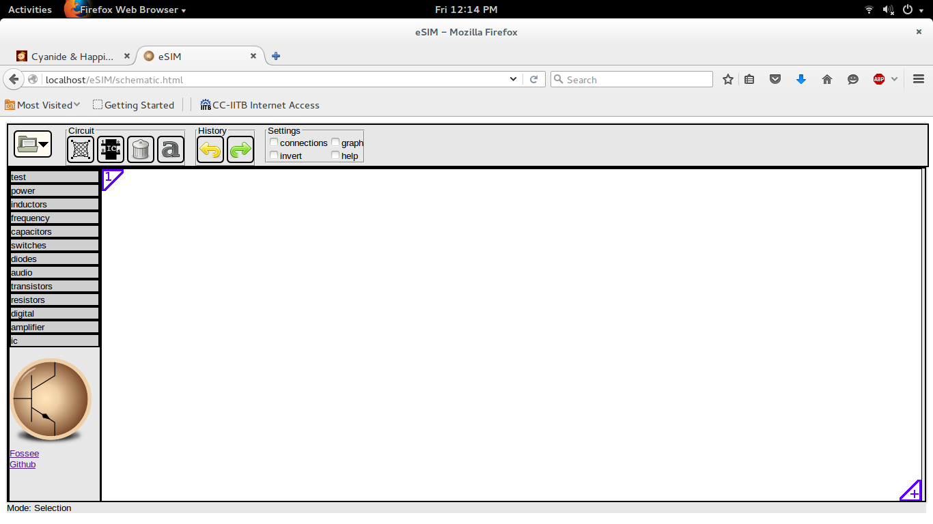

INSTRUCTIONS TO RUN:

1) On the left side of the page there are components required to ceate a circuit diagram.

2) Click on any sub category. Click on the component and drag the component to add it to the drawing board.

3)To make a connection between two components click on one end of the component and continue to end of the component and click on it .

4)For assigning values to components select it and then left click on it. This will give you option to enter values to components.

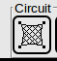
5) Once all the values are assigned click on the netlist button located on the top left of the menu bar written circuit on top of it.

6) On clicking that netlist display window will open.
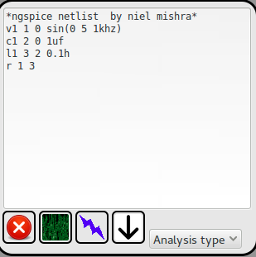

7)Click on the button analysis type and enter the values and units.

8)Once values are filled in click on the button save located on the let bottom of the window.

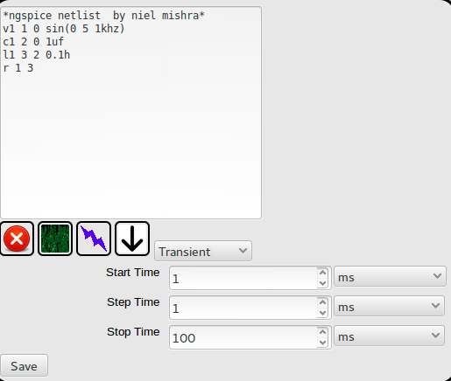

9) Next click on the netlist button which is green in colour and located on right to the close buttonon top of save. This will generate the ngspice netlist.
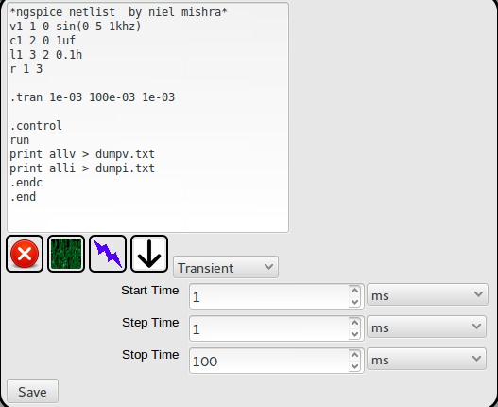

10) For simulation click on the button next to netlist generation button which has a bolt on it.

11) Once you do that a new window will pop up with the output as graphs.
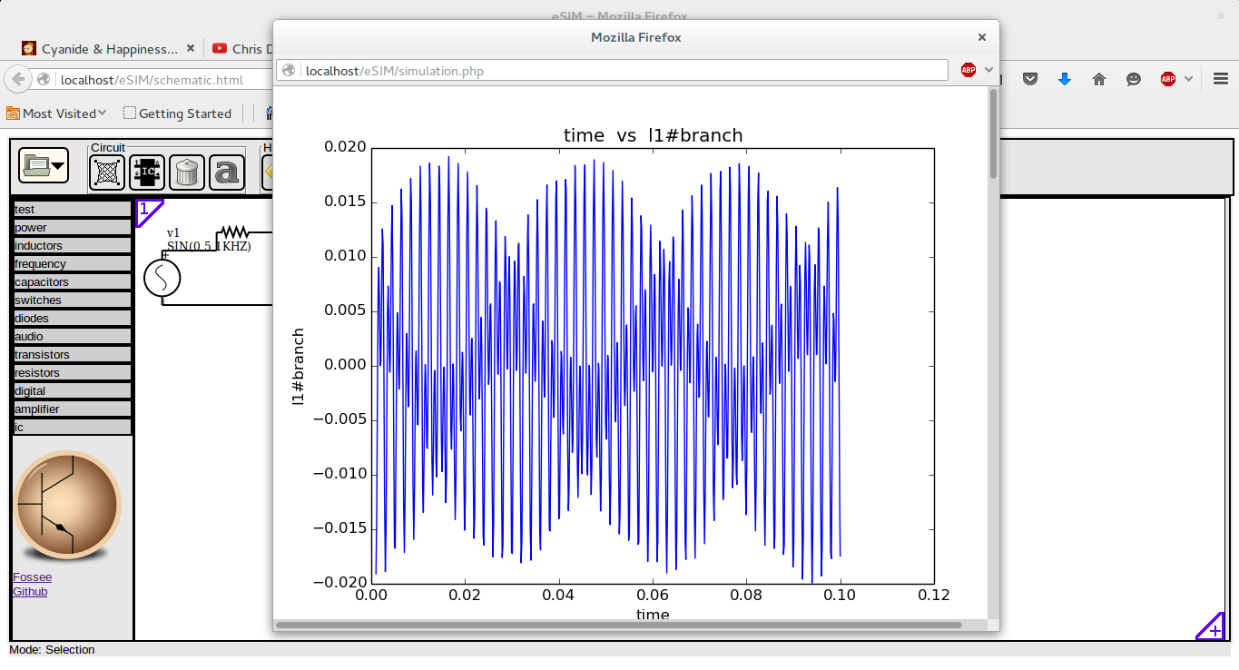
12) For downloading the netlist click on the download button next to simulation button.

13) For saving the graphs click on the graph ans use the option save as by right clicking on it.

